Mid-Hudson Region AACA
REFRESHMENTS Sign-Up Sheet 2026

Jan 14 Snacks: ___Laura Voght___Meeting Canceled ___
Drinks: __ Laura Voght ___ Meeting Canceled

Feb 11 Snacks: __Stephanie & Vince Naccarato
Drinks: __ Stephanie & Vince Naccarato

March 11 Snacks: ___Mary Sanford
Drinks __ Mary Sanford

April 8 Snacks: ___________________________________________
Drinks: ____________________________________________

May 13 Snacks: ___________________________________________

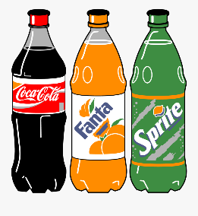
Drinks: ____________________________________________
REFRESHMENTS Sign-Up Sheet 2026
June 10 Snacks: ___Laura Voght
Drinks: ___ Laura Voght

July 8 Snacks: ___________________________________________
Drinks: ___________________________________________

Aug 12 Snacks: __________________________________________
Drinks _________________________________________

Sept 9 Snacks: ___________________________________________
Drinks: ____________________________________________

Oct 14 Snacks: ___________________________________________
Drinks: ____________________________________________

Nov Snacks: ___________________________________________

Drinks: ____________________________________________

